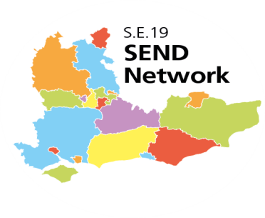
Preparing for Adulthood (Post 16) S.E. Regional Network Meeting
Terms of Reference

Frequency of meeting:
3 times a year

Purpose of meeting:
- To share progress, ideas, challenges and solutions in Preparing for Adulthood implementation across the S.E. Region
- To offer a topic based approach with input from Local Areas wishing to share progress in different areas, for example; personal budgets, joint commissioning and integrated working
- To develop responses such as amalgamated information and draft policy frameworks on topics as requested by the SEND Regional Steering Group and feed back to that group
- To develop a trusted network that can provide informal and formal peer support and challenge to facilitate the SEND Reforms

Membership:
- One nominated representative from each local area. This person to link to education, social care, health and service users within their Area
- DfE SEND Adviser for Region
- NDTi Preparing for Adulthood Representative for Region
- NHS England Representative for Region
- EFA/SFA representatives
- National Network of Parent/Carer Forums Representative for Region
- Other local area members as appropriate to the agenda

Reporting:
- Agreed Local Area to report back to and from the SEND Regional Steering Group
- Key outcomes from meetings to be fed into NDTi PfA monitoring report to DfE

