Models of Social Work Across the Region

South East Sector Led Improvement Programme

Project Sponsor: | Nikki Edwards  DCS Bracknell Forest
SESLIP Consultant: | Diane Williamson
Contact: dianewilliamson27@gmail.com

Contents
Section | Title | Page
 | Foreword | 2
 | Chapter 1 – Family Safeguarding Model
1.1 | Overview of the model with key features and evidence base | 3
1.2 | Who uses the model? | 4
1.3 | Evaluation and impact | 4
1.4 | Drivers and challenges | 9
1.5 | Funding and costs | 10
 | Chapter 2 – Signs of Safety
2.1 | Overview of the model with key features and evidence base | 11
2.2 | Who uses the model? | 13
2.3 | Evaluation and impact | 13
2.4 | Drivers and challenges | 19
2.5 | Funding and costs | 19
 | Chapter 3 – The Hampshire Approach
3.1 | Overview of the model with key features and evidence base | 20
3.2 | Who uses the model? | 21
3.3 | Evaluation and impact | 22
3.4 | Drivers and challenges | 25
3.5 | Funding and costs | 26
 | Chapter 4 – The Team Around the Relationship
4.1 | Overview of the model with key features and evidence base | 28
4.2 | Who uses the model? | 29
4.3 | Evaluation and impact | 30
4.4 | Drivers and challenges | 32
4.5 | Funding and costs | 32
 | Chapter 5 – Connected Practice
5.1 | Overview of the model with key features and evidence base | 33
5.2 | Who uses the model? | 38
5.3 | Evaluation and impact | 38
5.4 | Drivers and challenges | 38
5.5 | Funding and costs | 40
 | Chapter 6– Local Authority Contacts
6 | Local authority contacts for each model | 41

Foreword
In 2019 SESLIP initiated a project to share and develop new models of social care practice that “fit the times”. The Directors of Children’s Services recognised that authorities are questioning their models of social care practice. Some are seeking to integrate early help and social care and would value some collective thinking about how these services are delivered in this new context. Some large local authorities have been spending significant amounts to deliver major systems changes. The project aims to investigate the options for shared learning and other collaborative approaches to support new models of practice. The first stage of this work involved collating information about models of practice that are being used across the region giving us an overview of models that are currently in use and a summary of areas of commonality and challenges with the intention of presenting these at a conference in June 2020. The conference was cancelled due to the Covid-19 pandemic. Instead the information gathered has been brought together in this document.
The table below shows the models in use of across the region in Autumn 2019:
Model | Only / Primary Model | Alongside other models
Family Safeguarding Model | Bracknell Forest  Surrey  West Berkshire | Oxfordshire  Portsmouth
Restorative Practice | Southampton | Oxfordshire  Portsmouth
Signs of Safety | Medway  Milton Keynes  West Sussex  Windsor & Maidenhead  Wokingham | Kent
Strengthening Families | Buckinghamshire
Systemic Practice Model (in development) | Slough
The Team Around the Relationship (Bespoke) | Brighton and Hove
Connected Practice (Bespoke) | East Sussex
The Hampshire (and IOW) Approach (Bespoke) | Hampshire  Isle of Wight
Trauma Informed Model of Care (TIMOC). |  | Portsmouth

This paper provides detailed information about the models of practice that would have been presented at the Models of Social Work Conference in June 2020:
- Family Safeguarding Model
- Signs of Safety
- The Hampshire Approach
- The Team Around the Relationship
- Connected Practice

Family Safeguarding Model

Overview of the model with key features and evidence base

The Family Safeguarding Model (FSM) is a way of keeping families together where it is safe to do so. This is achieved through a more collaborative way of working where parents are motivated to identify the changes needed within their own families. This helps achieve better outcomes for children. The approach uses Motivational Interviewing. This is designed to empower and engage parents to make the positive changes needed to achieve improved outcomes for their children and their own wellbeing.

The model brings together children’s social workers with specialists in adult mental health, domestic abuse and substance misuse. This integrated support has helped to reduce the numbers of children coming into care and costs across public services.

Key features involve the teams:
- being multi-disciplinary and co-located
- delivering a whole family focus by spending more time with children and families
- achieving change through the skilled use of motivational interviewing techniques
- using high quality reflective supervision, including group supervision within a multi-disciplinary forum, to support information sharing and strengthen decision making
- using a range of tools to develop an in depth understanding of family functioning
- using a workbook to aid streamlined recording and ‘real time’ assessment
- implementing group work programmes once adult specialist workers are in post

Who uses the model?

Bracknell Forest, Surrey and West Berkshire are using FSM as their primary model of practice with funding support from DFE. Portsmouth and Oxfordshire are using FSM alongside other models. Oxfordshire are using it alongside Restorative Practice and Motivational Interviewing and Portsmouth are using it alongside Restorative Practice and Trauma Informed Model of Care (TIMOC).

The FSM was introduced in the 2 locality-based teams in West Berkshire in October 2017, delivering child in need (CIN), child protection (CP) and children subject to Public Law Outline

Bracknell Forest has had a fully staffed multi-disciplinary team (MDT) since August 2018. The model is used by long term child in need (CIN), child protection (CP) and Looked After Children (LAC) teams and by partners in Health, Police, Substance Misuse and Domestic Abuse.

Surrey started to implement the model in 2019 and MDTs are for CIN, CP and children subject to Public Law Outline

Evaluation and impact

FSM is being evaluated by York Consulting. The first evaluation was undertaken in Hertfordshire in 2017.

The evaluation consists of three strands:
- qualitative and quantitative data on the process of change
- a comparison of practice, service experiences and outcomes prior to, during and after [FSM] implementation
- analysis of a large dataset that included evidence on service use and outcomes for all children and parents in every family allocated in [FSM], for the 12 months from August 2015

In this original implementation, “A huge amount was achieved within a very short space of time, including commissioning and delivering a large training programme for all staff; recruitment of new specialist adult workers; creating multidisciplinary teams; introducing new ways of working, and reducing caseloads. Effective management oversight and strong interagency working meant that the key planks of [FSM] were put in place swiftly, challenges were generally overcome and the reforms were delivered in an impressively efficient manner” (pp 9-10)

Feedback was mixed, “there was a substantial reduction in caseloads. The training in MI was delivered, but was of mixed quality. The qualitative feedback for other elements was also mixed, with case discussions being a generally positive element of the changes, while workbooks and the structured work were less well received. In addition, a sense of energy about the project, and commitment to working to keep families together, were evident … Workers’ levels of stress, satisfaction and intention to stay in the job were influenced by factors both within and beyond the reform programme, with line managers having a particularly important role. Other crucial factors included access to adult workers, individual workloads and stability at team level” (p10)

In the comparison of practice before, during and after implementation of FSM worker skill was rated for “care and engagement and good authority skills … Level of skill has been found to be linked to outcomes for families in research in other authorities.” The evaluation showed “a small, though not statistically significant, shift in care and engagement skills … However, the shift in good authority was statistically significant… This was particularly linked to greater clarity about concerns with families. The evaluation also demonstrated that “the quality of practice improved over the course of the year of the evaluation, and, in particular, that it continued to improve after the initial implementation of the new approach”. (pp10-11)

When looking at the impact on outcomes for children and families, “ICS data was compared for 221 families prior to [FSM] and 165 post-[FSM]. Here, there was a small reduction in the proportion of families who had a child enter care at some point, from 12% to 10%. However, the number of days children spent in care over the 5 months post-allocation was calculated for each family (including the majority who had no children enter care). This showed a reduction by more than half, from 20.5 days per family pre-[FSM] to 9.8 post-[FSM]. The change was primarily achieved by children being more likely to return from care, and to do so relatively quickly, post-[FSM]. This is an important positive finding in relation to [FSM], with implications for children and families, as well as cost implications.” (p11)

The evaluation concluded that “It is unlikely that these differences in outcomes are due to the modest shifts in skill observed. Evidence suggested that the specialist adult workers were particularly important in this respect. Quantitative analysis found far larger positive changes where adult workers were involved. ... The substantial contribution of adult workers, both to direct work with families and to helping workers in conversations about risk and change, was a major feature in these families. It seems clear that the inclusion of adult workers in teams for children and their families was a central success of [FSM], providing not just specialist input but also a move towards a more multidisciplinary way of thinking and talking about families, as well as working with them. This is likely to be linked to the positive effects on outcomes, and helps us to understand the particular impact on families with more serious problems, such as the reduced need for children to enter care.” (pp11-12)

One of the features of implementation of FSM is the multi-agency dataset. The potential benefit of this is highlighted in the evaluation. “The creation of a suite of key performance indicators (KPIs) that provided data for all families allocated in [FSM] … in relation to use of health, policing, education and other services was in itself an enormous achievement, and one of the most innovative elements of the programme. It has the potential to allow interagency oversight and governance by focusing on outcomes that are meaningful for both families and services. For instance, it was possible to examine police involvement or school attendance before-and-after allocation to a worker in [FSM]. However, the KPIs do not provide a comparison with equivalent data before [FSM], … They therefore currently provide limited evidence to evaluate [FSM] as a reform.” (p12)

The initial analysis of the Hertfordshire data showed that “when service use was compared for the months before and the months after allocation, there were substantial reductions in contact with the police (monthly contacts reduced by 66%) and emergency hospital admissions for adults (which reduced by one half on average). While these do not provide evidence about the impact of [FSM] compared to allocation prior to [FSM], they do provide a strong indication of the positive impact that allocation to a worker made to families on key service use measures.” (p12)

The Family Safeguarding KPI Definitions Toolkit can be found in the document below:

Between 2017 and 2020 Bracknell Forest have seen significant impact and reduction in demand:

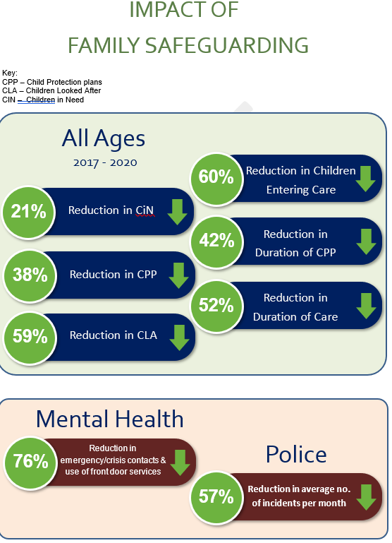

This initial evaluation of the Hertfordshire implementation “estimated some of the cost savings in the first 12 months of [FSM] that can be attributed to allocation. It should be noted that these are not a full estimate of cost savings: they are solely for the first 12 months and relate to indicators measured. The estimated cost savings to Children’s Services from reduced care and child protection allocations in the first 12 months alone were £2.6 million. For the police and health, too, there were savings related to families being allocated in [FSM]”. (p12)

York Consulting Limited are evaluating the implementation of FSM in Bracknell Forest and West Berkshire. The full evaluation is due for completion by Autumn 2020.

Bracknell Forest report that the interim evaluation report from York Consulting Limited confirmed that the workforce is happier and feels greater job satisfaction and that staff support this more innovative and new way of working. Later analysis from the evaluators in 2019 also suggests that mental health impact across the service is strong, that is a reduction in depression and anxiety and a reduction in crisis contacts. From the early internal analysis for impact we see that FSM in Bracknell Forest (Family Support cases only) can evidence over £2m per annum in cost avoidance due to a reduction in children coming into care, a reduction of children on CP plans and a higher proportion of families being worked with at the earlier points. FSM is now being spread across into the ‘front door’ services (early 2020) at Bracknell Forest and they are seeing the ‘green shoots’ of impact there. This means Bracknell Forest is able to work earlier with multi-disciplinary input which is ‘stemming the flow’ of cases in to later parts of the system be it Family Support or Children Looked After (CLA) services. E.g. front door staff are carrying out drug testing and visit jointly with our adult specialists at first point of referral. Adult workers are also attending strategy meetings

West Berkshire report that the interim evaluation has evidenced that this way of working has transformed how we work with families and has enabled more families to stay safely together. The authority reports that the interim report from York Consulting Limited has provided evidence that the workforce has a much higher rate of job satisfaction, caseloads have reduced and families feel that they feel we work with them to keep their family together. The evaluation of the impact of FSM has evidenced over £3M of cost avoidance to the local authority due to a reduction in children coming into care (family safeguarding cases), a reduction of children on CP plans and a higher proportion of families being worked with at CIN.

Drivers and challenges

The evaluation of the implementation of the FSM in Hertfordshire is of the opinion that “the [FSM] innovation is not just important for what has been achieved within Hertfordshire; but, we feel, there are also national lessons” (p13). These lessons relate to multi-disciplinary teams, changes in practice, leadership and development of KPIs.

Multi-disciplinary teams are a core feature of FSM, “multidisciplinary working requires more than simply recruiting adult specialists; processes such as group case discussion and a framework for practice, in this case MI, are necessary to make this a genuinely multidisciplinary experience, and to provide a framework for helpful discussion and new ways of thinking” (p15).

Multi-disciplinary teams need to be underpinned by clear governance, management and supervision arrangements. For example, in West Berkshire, specialist practitioners are employed by their partner agency and continue to get clinical supervision from their agency, whilst the FSM team manager holds overall case management responsibility.

The Hertfordshire evaluation reports that, prior to implementation of the FSM in Hertfordshire, practice “was characterised by little empathy and an approach that often involved telling parents what to do. This is an approach which research suggests is unlikely to create meaningful change, though it is nonetheless common in Children’s Services.” (p13). One of the common challenges of implementing changes to practice is that it takes time for these changes to become embedded as the evaluation points out “while the conditions for change can be put in place relatively swiftly, it takes time for workers to begin to practice in new ways” (p13).

Creating change in practice is challenging and about more than practical and process changes, providing training and taking time for that to take effect. It is about cultural change, changing the way the organisation and leaders and practitioners behave. It is about leadership and ownership. The Hertfordshire evaluation states, “Crucial for the successes in Hertfordshire was the sense of ownership and passionate belief in the reforms by the leadership team. This was communicated through the organisation as a set of values emphasising that social workers should work with families and seek to create change. This passion is not enough to create change on its own, but it seems unlikely that attempts to replicate promising models will succeed without similar levels of energy. Indeed, we felt this was one of the secret ingredients in Hertfordshire.” (p14)

Within the authorities implementing FSM in the south east region this challenge of cultural change is highlighted alongside the challenge of persuading partners of the benefits to them of MDTs and providing partner funding to sustain the model.

The final key national lesson is in relation to the creation of the interagency set of KPIs. The Hertfordshire evaluation is of the opinion that “these are genuine and measurable outcomes from the work of Children’s Services, for children, adults and the services concerned. The involvement of police, or use of emergency health services, are important outcome measures … [and] the suite of indicators provides an opportunity for strategic oversight of the service by a variety of agencies; and the influence of Children’s Services on the need for police involvement, school attendance or hospital admission can be monitored and developed. This provides a platform for coordinated and intelligent service provision” (p14).

Funding and costs

Bracknell Forest and West Berkshire both received an innovation grant from the DfE of £1.9m and £2.1m respectively to get the project started in 2017. The ongoing annual cost of the project (funding specialist staff) per year is £324,000.

Signs of Safety

Overview of the model with key features and evidence base

The Signs of Safety® (SOS) is an innovative, strengths-based, safety-organised approach to child protection casework. The Signs of Safety approach to child protection casework was developed through the 1990s in Western Australia. It was created by Andrew Turnell and Steve Edwards, in collaboration with over 150 West Australian child protection workers.

SOS is an approach built on working relationships between families and professionals that uses solution focussed and systemic questions to identify what families and professionals might be worried about and to balance this with strengths to help think about and build child safety. Children, young people, parents and the wider family and friend networks are supported to find solutions and build viable, family owned, long term safety plans that focus on the everyday lived experiences and care of children. As part of the process social workers will work with children, young people and families to help them find naturally connected adults who will be involved in developing, refining and monitoring safety plans for the children.

The approach has evolved over time using a collaborative inquiry approach with practitioners. At the heart of the Signs of Safety process is a risk assessment and case planning format that is designed to be meaningful for professionals as well as the parents and children. The SOS risk assessment process integrates professional knowledge with local family and cultural knowledge and balances a rigorous exploration of danger/harm alongside indicators of strengths and safety.

Three principles underpin the SOS approach:
- constructive working relationships between professionals and family members, and between professionals themselves, are at the heart of effective practice
- Munro’s Maxim: “Thinking Critically, Fostering a Stance of Inquiry” – professional curiosity
- grounded in practice - the Signs of Safety approach has been developed together with practitioners

Key features:
- a one-page assessment and planning protocol that maps harm, danger, complicating factors, strengths, existing and required safety, and a safety judgment. The Signs of Safety assessment and planning protocol, and the questioning processes and inquiring stance that underpins it, is designed to be the organising map for child protection intervention from case commencement to closure
  - what are we worried about? (past harm, future danger and complicating factors)
  - what’s working well? (existing strengths and safety)
  - what needs to happen? (future safety)
  - where are we on a scale of 0 to 10, where 10 means there is enough safety for child protection authorities to close the case and 0 means it is certain that the child will be (re)abused? (judgment)

- Signs of Safety practice disciplines
  - clear and rigorous understanding of the distinction between past harm, future danger and complicating factors
  - a clear and rigorous distinction made between strengths and protection, based on the working definition that ‘safety is regarded as strengths demonstrated as protection (in relation to the danger) over time’
  - rendering all statements in straightforward, instead of professionalised, language that can be readily understood by clients
  - all statements should focus on specific, observable behaviours
  - skilful use of authority
  - an underlying assumption that the assessment is a work in progress rather than a definitive set piece

- involving children – use of a set of tools
  - My Three Houses tool
  - Fairy/Wizard tool
  - Words and Pictures explanations
  - Child-relevant safety plans

- safety planning - a specific set of rules and arrangements created by the parents and support people that describe how the family will live its everyday life to show the children, the family’s own network, and the statutory authorities that the children will be safe in the future.

- drawing on organisational learning theories

Who uses the model?

Five authorities (Medway, Milton Keynes, West Sussex, Windsor and Maidenhead and Wokingham) are using Signs of Safety as their primary practice model and Kent is building on its implementation of Signs of Safety as it develops its model “Finding Safe Solutions for Families.”

West Sussex started using the model in 2012, Milton Keynes started in 2013 and relaunched in 2019, Wokingham started in 2014 and Windsor and Maidenhead and Medway started roll out in 2019.

In Milton Keynes, West Sussex and Wokingham the model is used by Early Help and all children’s social care teams.

Kent have developed an “eclectic approach to meeting needs and addressing risk, using ideas from Signs of Safety+ and recognising strengths. Systemic is a whole family approach and evidence -based change frameworks such as Motivational Interviewing and solution focussed are used to support and sustain change. Utilising approaches to safeguard and support families with the least scrutiny”

Evaluation and impact

The Children’s Social Care Innovation Programme Evaluation Report (July 2017 Dr Mary Baginsky et al) sought to address three questions:
- how is SOS delivered?
- what are the outcomes for children and young people?
- what are the costs of implementing SOS across children’s social care?

    - The findings from the local authorities’ strategic response were overwhelmingly positive about the benefits of SOS. Many of the challenges broadly reflect the challenges experienced by the South East authorities, irrespective of the practice model they are implementing, including recruitment and retention of social workers, high levels of referrals, constraints on budgets and reorganisations.

    - The greatest progress was reported in relation to:

- embedding an organisational commitment to SOS
- using plain language that could be readily understood by families
- using tools to engage children and young people, for example, Three Houses, Fairy/Wizard tool
- mapping cases, both by individual social workers and in teams
- using safety plans across initial and review child protection conferences and in all related groups
- providing advanced 5-day training for all managers
- embedding SOS approaches and principles across all training for those working in children’s social care
- aligning initial child protection conferences with SOS
- establishing practice leadership and supervision processes to support SOS

    - The weakest areas of reported change were in relation to:

- progress towards building constructive working relationships between professionals and family members
- spending the necessary direct contact time with adults in families
- confidence that the service was intervening at the right time
- creating a culture where it is permissible to admit mistakes
- supporting social workers with administrative tasks
- recruiting high-quality staff

Social workers were also broadly positive, reflecting a high level of engagement, albeit there was a lower rating from the most experienced cohort. Social workers reported:
- a reasonably high level of confidence in using SOS as a framework as well as in using the associated tools
- increased use of safety planning and mapping over the course of the evaluation
- using the Three Houses tool with nearly all their families but Words and Pictures to a lesser extent
- that the quality of their assessments had improved since the adoption of the SOS framework
- that safety planning, including mapping and scaling, helped to identify and manage risk
- that SOS helped to achieve better communication with families, and greater inclusion of children and young people
- there were also comments from social workers that they did not have the time to apply the approach as thoroughly as they would wish

The findings from families is based on the views of 270 families who were interviewed across 10 authorities. There were indications that:
- SOS had provided fresh opportunities for social workers to involve families to a much greater extent than had been the case previously
- SOS supported a greater degree of understanding between social workers and families
- SOS supported a more focused approach to goals and how they could be achieved
- where families said they had been involved in goal planning, they were more likely to report that their goals had been achieved, but the numbers are too small to draw firm conclusions
- just over half of the families interviewed considered that their social workers had not given them clear enough information about the criteria which social workers would assess their progress
- parents were more likely to say that social workers worked with their strengths when first interviewed than at second interview which may indicate that the planning developed in the early months is not being used effectively as the case proceeds

The findings of the work around resources, outputs and expenditure produced strong indications that suggest the SOS initiative is becoming embedded in pilots. A substantial amount of training has occurred, and pilots recognised the need to provide a continuous training cycle, despite the costs associated with both provision and attendance. In addition to providing matched funding and other overheads, a great deal of management time was required to support implementation. It was estimated that this amounted to a full-time commitment of one person in each pilot.

The analysis of expenditure ratios did not suggest that SOS had brought about sufficient practice and system change to influence overall expenditure patterns.

The Signs of Safety® Comprehensive Briefing Paper (4th edition) published in 2017, highlights that SOS is a mature and yet still evolving approach and that alongside the practice developments, significant parallel developments continue focusing on creating the organisational conditions that can support Signs of Safety use and implementation. In England there has been a focus on formalising organisational implementation processes that enable optimal use of the approach in practice.

What Works Centre for Children’s Social Care (WWCCSC) published a systematic review of literature on Signs of Safety research in November 2018. The aim was “to consider whether, how, for whom and under what conditions Signs of Safety works to safely reduce the number of children entering and re-entering care, and/or to increase the number of children re-unified with their family.” (p4)

The findings are summarised below:
- Signs of Safety is a widely used framework that aims to reduce the need for children to enter care, through a strengths-based approach
- this review found no evidence that SOS is effective in reducing the need for children to enter care. The evidence available for review was very low strength
- evidence on implementation of SOS was varied, and no standardised measure of whether SOS is being well implemented has been used
- embedding SOS may take a significant amount of time, but little is known about the journey from initial launch to full implementation
- there has not been a full economic evaluation of SOS, so we do not know how cost effective the model is
    - West Sussex are part of the evaluation of Signs of Safety EIP2 evaluation and have provided the interim report:
    - This follow up evaluation of SOS – EIP2 undertaken by Dr Mary Baginsky and colleagues in 2018 considered:

- implementation and fidelity - examining the transference of the approach into practice, alongside the perceptions of strategic leads, managers and frontline practitioners
- effectiveness and outcomes through an exploration of:
  - workforce outcomes –analysis of workforce data and workforce survey (4 pilots)
  - practice outcomes – observation of practice and analysis of case records
  - family and child outcomes - observation of practice and analysis of case records as well as feedback from parents, analysis of national data sets and WWCCSC work
- cost benefit study using data from 9 pilots and unit costing of any identified significant difference between pilots and statistical nearest neighbours (SNNs)
    - Some findings: implementation and fidelity

- most progress and strongest areas were changing organisational culture, a clear commitment for SOS from management, reporting of feeling like a safe organisation in which to work and informing, involving and listening to children.
- the challenges and weakest areas were providing appropriate levels of training and learning opportunities, embedding SOS in practice, establishing leadership at all levels, engaging Family Courts in the SOS approach, having sufficient time to spend with families, group supervision/appreciative inquiry in place and partner agency involvement
    - Some findings: effectiveness and outcomes (at March 2018 based on matching pilot sites with SNNs not using SOS, analysing national data from 2014-2018, including 31 outcomes covering CIN, assessments, referrals, LAC and workforce):

- the proportion of CiN with a case duration of more than 2 years was significantly lower in pilots than their SNNs
- the median duration of assessments was significantly shorter in pilots than their SNNs
- the proportion of assessments that started and finished on the same day was significantly higher in pilots than their SNNs (the assessment data were possibly influenced by two pilots with big changes is same day assessments)
- the rates of child protection conferences and plans were significantly lower in pilot sites than their SNNs
- no significant differences in repeat CP plans, care applications or LAC rate
    - Munro, Turnell and Murphy Child Protection Consultancy (MTM) have received two grants from the DfE English Innovations Programme to work with eleven local authorities to implement whole system reform to support Signs of Safety practice. The first grant funded 18 months’ work in 2014–16 (EIP1) and the second grant funded two years’ work carried out between 2017–19 (EIP2) and the evaluation report, “You Can’t Grow Roses in Concrete Part 2” pulls both projects together and examines progress over the five-year period.

    - The main finding is that, despite similar input from MTM, nationally the local authorities that have been part of this EIP have achieved very different Ofsted ratings with some rising to ‘outstanding’ and others falling to ‘inadequate’. The evaluation report states that “the Ofsted judgments are made independently of MTM but are consistent with other findings, judgments and impressions on the progress made in the local authorities.”(p3) The aim of the evaluation report was to explore how such variations in progress arose and draw out lessons on what factors have most influence (positive or negative) on the whole system reform and on how some authorities successfully achieved change and what impeded progress in others.

    - In summary, “the diverse progress made by the local authorities, in fact, illustrates the complexity of causation. Even where two local authorities take the same or similar action in broad terms, there is always variation in how it is then adopted and adapted within their organisational system and hence on its effect…The mixed results achieved by the local authorities correspond to the comprehensiveness and effectiveness of the implementations they undertook.” (p83)

    - The evaluation reflects many of the drivers and challenges highlighted in the responses from local authorities, irrespective of the model they were implementing.
    - In relation to the implementation of SOS the evaluation concluded that, “leaders in authorities that made most progress, were very visible and committed, getting close to the practice and showing that they understand its challenges. If whole system reform is delegated to middle managers, it is likely to falter because they lack the authority to make major changes”.(p83)
    - As highlighted by a number of South East authorities, the alignment of organisational processes and documentation and practice is critical. Where case management forms and processes do not fit the practice that workers are being asked to implement, they will either have to do the work twice or they will choose one directive over the other and their choice will be strongly influenced by the messages that they are receiving from senior and team managers. In the EIP evaluation, “practitioners’ frustration on meeting this obstacle was clearly expressed in comments in the staff surveys. Aligning the documentation and altering the software is also a clear message of commitment to implementing Signs of Safety. Aligning the documentation with the practice not only supports the frontline worker’s reasoning processes but helps the supervisor and senior managers monitor the practice.” (p84)
    - The evaluation also highlighted the role of adapting QA systems and the learning component of the organisational “Theory of Change” including introductory and advanced training and also stresses the importance of continuous learning and coaching.”
    - The evaluation emphasises the importance of cultural change. “The implementation of Signs of Safety can be described… by mainly looking at the visible changes made — changes to documentation, QA or learning opportunities. The other, less obvious dimension to consider is cultural change. The key cultural change task of EIP 1 and 2 was to move from a compliance and defensive culture that erodes time for direct work with families and the use of professional judgment to an organisation with a learning culture where the quality of work with families is the key driver. A cultural change that permeates the reforms is centred on dialogue and co-production within the organisation, replacing a more top-down approach to management.” (p85)
    - In the South East, Milton Keynes reports that the number of CP plans has reduced as had the duration of CP plans and using SOS for children on the edge of care has reduced LAC admissions. Wokingham reports improvements in permanence, placement stability, lifelong relationships and connectedness.

Drivers and challenges
    - The evaluations highlight a number of the drivers and challenges that have been reflected by the South East authorities that have implemented the model.
    - The Signs of Safety organisational implementation generally involves a preparation phase, two years of intense activity and three years of continuing development. For SOS to be used consistently across the organisation, and not just among the more enthusiastic practitioners in pockets of the organisation, requires active and engaged leadership.
    - A common challenge reported by South East authorities using SOS is around ongoing training and development in terms of cost and sustainability.
    - Another reported challenge relates to the fidelity of the programme and challenges being linked to the national programme, citing the need for approval from SOS being costly and time consuming and sometimes restricting local flexibility.

Funding and costs
    - The costs in relation to ongoing training, consultancy and changes to IT systems have been highlighted by local authorities.
    - The evaluations to date have not provided reliable cost benefit analysis

The Hampshire Approach (HA)

Overview of the model with key features and evidence base
    - Senior managers in Hampshire are clear that “the Hampshire Approach is about a mindset, our beliefs about our role and the families we work with.” That mindset is underpinned by practice, and also the knowledge and skills we have to work in this way. Hampshire is committed to boost the skills and knowledge of practitioners and managers alike through delivering the training and ongoing support on the practice model – an adapted approach encompassing the principles and tools of Motivational Interviewing, Solution Focussed Approaches and Restorative Practice.

    - The Children’s Services workforce believe that they need to work in a culture and organisation which supports this way of working – there is a vital link between the organisational commitment (structure and resource) to a strengths-based and family focused approach and practitioners feeling able to work in a strength-based way with families.

    - The leadership of the organisation supports and embodies this way of working too. The three elements of the HA are:

- family focused and evidence-based practice
  - the right support at the right time
  - outcomes for the family as a whole
- lean and effective service delivery
- dynamic and sustainable multi-disciplinary teams

    - Following scoping and a training needs analysis, the Hampshire workforce development offer lists the below training which supports the roll-out and embedding of the practice model: (this is a small selection)

- motivational interviewing
- solution-focused approaches
- supporting parents who experience child-to-parent violence
- disguised compliance
- listening and responding to families with complex needs

    - Hampshire commissioned the University of Winchester to develop a framework at the end of 2016. In Summer 2017, the University of Winchester produced an initial evidence paper on practice papers and models of building resilience, this formed the basis of ongoing discussions with staff. Following discussions with staff across the service about the themes, values, ways of working which should form basis of the framework, elements of the approach were rolled out in Spring 2018 and the model was introduced incrementally in 2018-19.

Who uses the model?
    - The approach was launched on the Isle of Wight in September 2019, following the successful implementation in Hampshire.

    - All staff who work directly or indirectly with families use a strengths-based approach. Practitioners who work directly with children and families use the direct work aspects of the model in day to day work.

    - It is used by all staff at all stages of the child’s journey. It is also a model that partners have sought to embrace, and the information sharing process for child protection conferences has been reviewed to reflect this approach. Hampshire has also taken their partners along with them on this transformation. It is very positive to note that partners (through the Hampshire Safeguarding Children Partnership) have requested input about the Hampshire Approach so that they can align their input with the social work model and deliver the same messages to children and families.

    - Hampshire operates a district model of delivering services to their children and families. A district has several teams operating within its structure including the Early Help Hub/Family Support Service, Children’s Assessment and Safeguarding Team (CAST) which predominantly work with child protection and child in need cases, Children in Care Team, Children with Disabilities Team, and Care Leavers Team. All these teams have administrative support both from generic administrative officers and SWPAs, who are a group of skilled support staff who deal with social workers’ administrative tasks and have regular contact with families.

    - There are also county wide services: Adoption, Fostering, Residential Service and the Independent Reviewing Service.

    - The Multi-Disciplinary Working (MDW) service started in April 2019 but the Family Intervention Team (FIT) model of working has been embedded since 2016. All the above practitioners including first- and second-line managers have been trained in the model (with Restorative Practice being rolled out in December 2019) and use the strengths-based approach in practice.

    - Senior managers and leaders in Children and Families model the approach to their colleagues and there is a commitment and determination from leaders to use the practice model and successfully embed this as our way of working.

Evaluation and impact
    - DfE evaluate the model as this is funded Partners in Practice and evaluated as part of the wider transforming social care programme in Hampshire.

    - Initial evaluation report conducted by External Evaluators Oxford Brookes concluded that the changes had progressed at a steady pace and was beginning to show a positive impact on outcomes for family resilience and staff wellbeing.

    - The Hampshire Approach (HA) practice model is now business as usual. Consequently, any success is measured through embedded quality assurance processes like case file audits, practice observations, peer inspections, participation feedback, Bright Spots survey, compliments, complaints and comments.

    - Performance management is a cornerstone for measuring the rigour and impact of interventions with families and this data is interrogated in detail by staff and managers on a regular basis.

    - Performance management information shows the following since November 2018. It is important that these statistics are seen as being impacted on by a wide range of factors (not just the HA Practice Model) including the technology solutions, establishment of multidisciplinary teams and shift and leadership and management models (data correct as at 2019):

- 23% reduction in Child Protection Plans
- 4% reduction in Looked After Children
- 30% reduction in social work caseloads
- 30% of staff spending less time travelling as a result of mobile working
- 92% of files audited showed improved outcomes for children Anecdotally, families are finding the new C&F assessment much more family and child centred

    - There is also the Embedding Change Dashboard which enables tracking of adoption of changes delivered by the overall HA, of which the practice model is one element. An excel tracker (see below) is used on a monthly basis to measure how changes are being embedded and the Embedding Change Dashboard, which is a set of slides of the data distilled from the tracker, is presented to the senior managers responsible for driving these changes. An example under the HA umbrella is:

Area being measured – Plans in X district
TSC Outputs | Description of measure | Definition of measure | Source | X District/Service Data and BRAG rating
Plan | Staff confident in strengths-based plans | % of survey respondents | Checking the pulse survey* | 90%
 | Plans complete using the new template | Plan audit | Service Manager | 100%
 | Plans written using strengths-based language |  |  | 69%
 | Plans with all sections complete |  |  | 77%

    - There is currently some work underway to gather feedback from families with regard to the impact of the use of the practice model. Below are comments gathered as part of feedback – “Voice of children, families and professionals”: This is feedback related to the C&F assessment and the CLA care plan, which are one of the first areas of practice that Hampshire wanted to deliver an impact on.

- “it was great our social worker could send me forms instantly, and they came to my phone while I was with her.”
- “she now wants to come to her CLA review as she’s completed her own care plan, she’s never been interested before.”
- “…able to quickly share information with parents and even play YouTube during contact; meaning everyone can "enjoy" Baby Shark, wherever they are!”
- “best format I have seen. Very child focussed. Young person liked it and took ownership of it. I liked it too”
- “my favourite thing about the assessment is that I like the format and how it is written. I believe it is much easier for the families to understand the reason for Children’s Services involvement but also encourage them to recognise their strengths and participate in the process”
- “the families that I have shared the new assessment with have informed me that it is much easier to read and understand compared to the previous one”
- “the new assessment encourages families to become more engaged in the process because it enables them to recognise what they are doing well and what support they feel that they need. In effect this has also improved building a rapport with families and ensuring the child remains at focus”
- manager at out-of-county residential unit on updated C&F form: “Best format I have seen. Very child focussed. Young person liked it and took ownership of it. I liked it too”
- early years on CP conferences: “I liked how each parent was named prior to any point made, showing personal respect. Any negative comments or pointers thereafter seemed slightly easier for the parents to take on board. This compares very positively to previous conference … It is my belief that this new system will hopefully encourage parents to be more willing to cooperate without feeling constantly reprimanded and focus on positively enhancing their parenting skills.”

    - Checking the Pulse Survey conducted in October 2019 returned over 200 responses from practitioners who have commented overwhelmingly positively about how using the HA working in a strengths-based and family focussed way has encouraged them to think and act differently

    - Excerpts from Ofsted full ILACS Report June 2019:

- staff are skilled at using ‘strengths-based’ approaches and empowering children and families to take control of their plans. This is having a particularly positive and tangible impact on children’s outcomes.
- social workers are highly skilled at building and sustaining enduring relationships with children. This is a considerable strength in Hampshire.
- social workers undertake creative, tailored, direct work with children to help them to understand their situation. Social workers eloquently reflect the child’s experiences in case recording, writing to them personally, which provides a powerful sense of the child, supporting children’s understanding of why decisions are made. This is strengthened further by well-written, thoughtful, child-centred assessments, which bring children’s experiences to life and provide a palpable sense of their lives.
- the HA permeates the work with children and families, building confidence and resilience and leading to positive outcomes for children
- tenacious and creative work is undertaken to support children to safely remain in the care of their families wherever possible. Intensive support workers demonstrate skill through their sensitive, relationship-based work with families

    - You tube video of Hampshire’s journey to Outstanding:
https://www.youtube.com/watch?v=f1FBIpZ2WXc

    - Health and Wellbeing questionnaires are completed in every district and service at least once a year and as often as an employee wishes to. Staff have mostly agreed that using the HA has helped to change their thinking/approach and that direct interventions with family are focussed on the strengths of the family whilst holding the children at the centre of the work and risk assessment and management being interwoven into day to day practice.

  - Drivers and challenges

    - Hampshire mapped the areas of influence which would have the biggest impact on embedding the practice model, both challenges and enablers. The span of influence was seen as a continuum, rather than as a static challenge factor, which meant the ability to move it along the continuum towards embedding change was built into the design.

    - In preparing to roll out the HA practice model, a lot of background work was undertaken. A national scanning of the practice landscape in other local authorities, collating and analysing research and speaking to practitioners highlighted that the change journey was more than a sum of all its elements.

Our
Mindset
Organisational
Cultural

Our knowledge skills and learning
Our
practice

Leadership

    - Leadership - Leading by example is an oft used word which is accompanied in many instances by an unclear narrative, which changes often. With the HA, it was agreed that this would be embedded in a way that truly reflected Hampshire’s drive and commitment to lead by example. Staff from the Director to the Heads of Departments and operational leaders, all practice a strengths-based approach with a clear emphasis on recognising and enhancing excellent practice. The other element of strengths based working that leaders are embracing, with its challenges, is the importance of being a learning organisation and using experiences to learn and develop as practitioners and managers.

    - Culture - the longest and most challenging shift as it encompassed values, resilience, tested and tried models of management, recruitment and retention and individual, team and community approach to safeguarding children. It is truly a whole system cultural change. Once recognised as a major enabler, leaders and influencers embraced this as the bedrock of the approach, and that it would not be as easy as giving staff a manual to follow to change practice

    - Organisation - Embedding the HA practice model and ensuring there is consistency in a local authority as big as Hampshire, with 8 districts and several standalone services has to be a collaborative, well planned, well-resourced and well led process. The HA practice model was developed under the umbrella of the Transforming Practice and Transforming Social Care programmes which has several workstreams running and now the HA is business as usual in Hampshire

    - The elements of mindset, skills and knowledge and practice are all interwoven within the above 3 areas i.e. ensuring that we equip staff with right training, coaching and modelling strengths based leadership, aligning all of our processes, policies and practice guidance with the model – e.g. supervision policy, CP plan, child and family assessment, hearing the family and child’s voice to influence positive outcomes are all part of the big picture.

    - Despite the magnitude and significant challenges of this journey, Hampshire is proud to say it is ‘learning to plan and planning to learn’ at all times.

  - Funding and costs

    - HA is business as usual and there is an operational and service budget for this. There is PiP funding for some aspects of the ongoing work to embed all the elements of the model and currently the Multi-Disciplinary Working project sits under the Transforming Social Care Workstream.

    - The DfE has funded the build and implementation of the Transforming Social Care Programme through the Innovation Fund and the PiP programme. These funding streams continue to look at continuous improvement of the HA practice model.

    - There has also been substantial corporate investment, and as the HA practice model is now in the embedding phase as ‘business as usual’, this is accounted for within the operational budget for workforce development.

The Team Around the Relationship

Overview of the model with key features and evidence base

    - In Autumn of 2014, managers in Brighton and Hove began looking at implementing a model of practice across Children’s Services to improve outcomes for children. At the beginning of 2015 the authority set up an advisory group for children and young people, held workshops with staff and a Relationships in Practice Conference, which included presentations by Jenny Molloy and Professor Donald Forrester. The model of practice was implemented in October 2015.

    - “At its best, what social work can offer to people in need of help is a supportive and understanding relationship which will enable them to resolve their difficulties and to feel enhanced rather than undermined in the process” (Ruch, 2010).

    - Eileen Munro’s review of the child protection system highlighted that social work practice had become over-bureaucratised and procedural, with a focus on recording and compliance rather than direct work with children, young people and families. In order to challenge this, and social workers’ experience at that time of working for the service, Brighton & Hove wanted to introduce a practice model which allows social workers to build relationships with families and not just records about them. They wanted to develop an organisation which supports social workers to spend as much time as possible with children and families and also recognises and contains their professional anxiety.

    - Relationship-based practice is founded on the notion that a social worker’s relationship with the family is the most powerful tool to facilitate change and that these relationships, when they are trusting, empathic and authoritative, can be reparative.

    - Relationship-based practice is not about a specific intervention or way of thinking but is about prioritising direct work with families, moving away from social workers co-ordinating cases to social workers working with families, and applying a range of skills and interventions in a thoughtful and purposeful way. The model recognises that human behaviour is complex and multi-faceted and so a practice framework cannot be based on a single skill set. Instead the model’s theory of change is that, if social workers feel supported and contained, they can build relationships with families and use these relationships to facilitate change with families based on an understanding of the family’s unique experience and the social worker’s practice expertise.

    - The approach is also underpinned by a confidence in professional authority, expressed by working in partnership with families with a focus on outcomes and being explicit about what needs to change – social workers need to be confident and skilled at holding difficult conversations with families. It is important to emphasise that a social worker’s relationship with a parent is not an ‘end in itself’; the relationship is the means by which a parent can be helped to affect change which improves his or her quality of life, but most importantly the quality of life of the children of the family within the children’s timescales.

    - Within this model of relationship-based practice, the social work relationship becomes the main practice tool, at the heart of a system of relationships built to support the child and family – what Brighton and Hove call the ‘team around the relationship’ model. – and this requires small teams of social workers, (up to 7 full-time equivalent social workers supported by a pod manager and business support officer), who support families across the service, know the families they are each supporting and can work collaboratively - the pod. The key principles of the model are:

- continuity of relationships between social workers and families
- consistency of relationships between social work teams and families
- collaboration between practitioners
- social workers being purposeful partners in change with families
- the organisation supporting a learning culture, and
- a transformation of the organisational culture from a blame culture to a relationship-based one that inspires trust and confidence

    - This model of practice promotes the importance of reflective practice and good quality supervision throughout the organisation, recognising that supportive relationships between social workers and their managers and peers enhance relationships between the worker and the family and these relationships in turn have the power to impact positively on relationships between parents and children. All social workers take part in 1:1 supervision with their manager, weekly group supervision with their pod, and monthly reflective practice groups with peers from across the service. The supervision model focuses on providing containment for workers’ professional and organisational anxiety so that they can then think about families in a purposeful way.

Who uses the model?

    - The model is used by all children’s social work services, including generic social work pods that support families all the way across their journey with us, adolescent services, adoption and fostering services, children’s disability services, the Partners in Change hub, that provides specialist support, and leaving care services.

    - Early help practitioners are also sharing the principles and the recording system developed to support the model.

Evaluation and impact

    - The model is measured against the following outcomes:

- improving the experience of children and families
- developing the skills and satisfaction of the workforce
- supporting safe and stable family lives, and
- improving performance against proxy indicators of these outcomes, such as the number of children with a child protection plan due to being at risk of significant harm

    - The model was formally evaluated in July 2017 in association with the University of Sussex, Centre for Social Work Innovation and Research and a report was compiled by the Model of Practice Working Group. The evaluation recognised contributions of staff, foster carers and the young people and families they work with in developing and evaluating the model of practice.

    - The paper, Empathy, tenacity and compassion: an evaluation of relationship-based practice in Brighton a Hove, outlined the findings of the evaluation and set out the key messages from the first 20 months - in doing so it captured the implementation of the new model as it was emerging as part of a cycle of continuous evaluation. It was principally presented in the words of practitioners and the families they work with, supplemented by examples from practice, in order to provide a richness and depth to the findings. The title was taken from a parent’s description of the qualities demonstrated by the social worker supporting their family.

    - The evaluation found that, in general:

- families have a better experience of social work
- social workers feel more supported and more able to make a difference for families
- relationship-based practice seems to be supporting safe and stable family lives for children, and;
- the model of practice appears to have decreased demand for social work and high-level interventions during a time of increasing national demand

    - Ongoing evaluation includes consideration of service-user feedback, social work satisfaction and performances against key indicators (see graphic below) and plans are being developed for the next stage of the evaluation to be led by families.
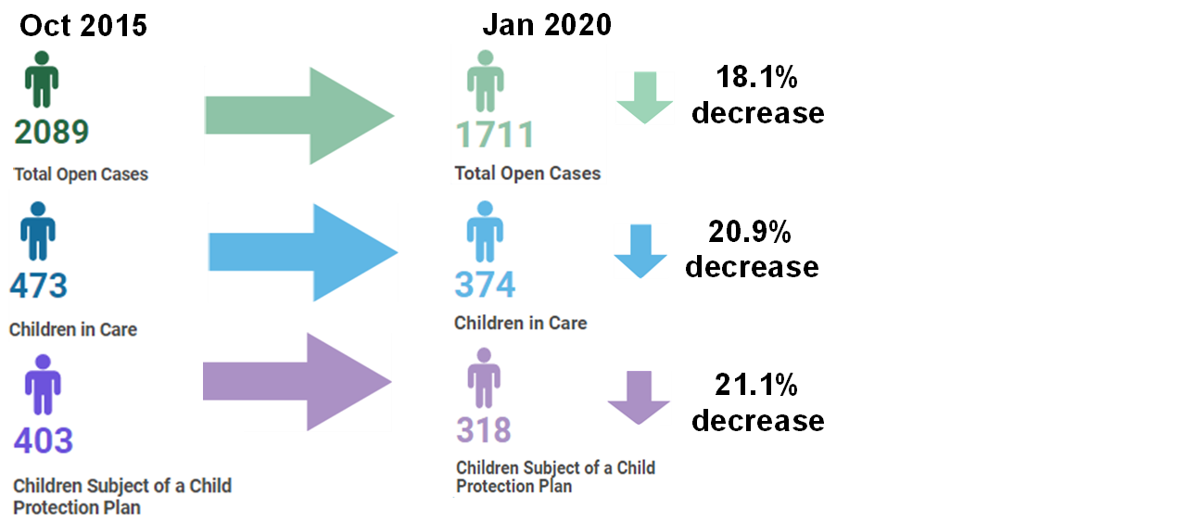

    - The impact for the organisation is also considered within the evaluation report and ongoing work:

- at July 2020 average number of children allocated to each social worker were 15. This has decreased from between 18 and 19 children in October 2015
- workforce data shows a large reduction in staff vacancies and the employment of agency staff between 2015 and 2020. Brighton and Hove no longer employ any agency social workers in children’s social work and currently have a full establishment. This is supported by regular ongoing recruitment and an annual recruitment of a cohort of newly-qualified social workers for their ASYE
- turnover and sickness rates remain fairly constant

    - Your Voice: social work survey, Brighton and Hove’s version of the social work health check has been completed on an annual basis since 2016 and has shown a consistent increase in social worker satisfaction.

    - The impact of the model was also considered as part of Ofsted’s report of their ILACS inspection in August 2018:
“Since the last inspection in 2015, targeted financial investment has supported a service redesign. The new model of practice has been embedded and is resulting in greater continuity of social work relationships for children and families. Outcomes for children are largely positive and, frequently, risks are reducing, particularly for hard-to-reach, vulnerable adolescents…. Social workers’ morale is high, and workers spoken to as part of the inspection told inspectors that they enjoy working in Brighton and Hove”

  - Drivers and Challenges

    - The challenges identified by Brighton and Hove are broadly similar to the challenges experienced by other authorities implementing other models in terms of the time needed to change culture, embedding the model of practice and ensuring consistency.

    - The change was made within the context of the ongoing impact of austerity for families and the reduction of early help and preventative services leading to chronic and complex problems for families. This was alongside the ongoing impact of reduced budgets and funding for local authorities.

  - Funding and Costs

    - The implementation of the new model of practice was completed within the existing budget envelope for core children’s social work funding and this has included reviewing and redirecting budgets for training and evaluation.

    - Implementation of the model has facilitated a significant reduction in costs associated with agency staff, legal fees and placements for children in care based on the outcomes described above.

Connected Practice

Overview of the model with key features and evidence base

    - Connected Practice was developed by East Sussex County Council in 2016 after looking at a number of high performing local authorities most of whom had undergone a full system change either implementing systems theory / reclaim social work / hub model as well as Signs of Safety. The consistent message from all the really high performing local authorities was that it didn’t matter what kind of model you adopt, the most important thing was that all parts of the organisation have the same understanding and approach in how you work with families, from the top of the organisation to the frontline practitioner.

    - Connected Practice is a methodology that supports practitioners to create change through meaningful and helpful relationships with children and families. Through these supportive relationships more children and young people are supported to stay at home with their families, leading lives that are safe, stable and fulfilling. If the child cannot remain at home decisions are made in a timely way. The same focus on relationships remain ensuring the child secures a strong sense of belonging within extended family or with carers and, where helpful, retains a connection with their birth family.

    - Families, carers and children will have more relational, effective, structured interventions and this will promote their functioning allowing for children in their care to be safer and better nurtured.

    - For East Sussex, this focus on relationships and strength through connections is reflected in their approach to working with families, their career pathway and CPD and their practitioner well-being programme.

    - Practitioners draw on their own resources to develop effective relationships with families, carers, children and young people. Working intensively to help families and carers to solve problems themselves and create change, without having to refer to others to create this change.

    - In order to support practitioners, the organisation ensures they are valued and treated with dignity, allowing this experience to cascade down to the families with whom they work.

    - Everyone who works in East Sussex will adopt the same approach and understanding regarding vulnerable families. This consistent understanding is underpinned by the following questions which are contained in the child’s plan:

- why is the family or carer functioning as they are? How has past experience and/ or trauma impacted on the current situation? (what are we worried about)
- what are the strengths that we can harness within this family/ carer and extended family to create change? (what is working well)
- what can the social worker contribute to support the family or carer to improve their functioning in order to keep the child safe/ meet the child’s ongoing needs? Time is a crucial element in work with children and should be reckoned in days and months rather than years. (action)
- if there are current risks how can we keep the child, family or carer safe whilst this change work is occurring?
- what will it look like when the child is safe/ thriving? (how will we know when things have improved)

    - Connected Practice is informed by:

- motivational interviewing
- attachment and trauma informed practice
- solution focused approach
- parenting theory and skills workshops
- mentalization
- systemic approach
- adult attachment interview
- attachment style interview
- thrive
- therapeutic parenting programme

    - Tools that support this change work:

- single source
- communication and participation toolkit
- mental health self-help guides
- safer relationships programme
- neglect toolkit/ neglect matrix
- digital toolkit
- SWIFT consultation and intervention

    - Systems that support change:

- group supervision
- practice development
- team based learning
- practice lead model – supported by SWIFT (Multi-disciplinary Specialist Safeguarding with Intensive Family Treatment Service
- strengths based case conferences
- placement support service
- buddying system for carers
- introduction of a case summary tool (less time recording more time with children)
- the same plan travels with the child from CIN continuing from Through Care and into adulthood
- all staff are trained in the same approach from front line practitioners to senior management

    - Systems that sustain change:

- for families and carers:
  - family and friends – Family Group Conference / Family Network Meetings
  - placement support services
  - community based support – school / health / neighbourhood
  - effective early help – Pro-active step up/ step down
  - children, families and carers involved in development of services.

- for practitioners:
  - clear understanding that in East Sussex relationships come first underpinned by knowledge in MI, attachment and trauma

    - Connected Practice is not just a practice framework but it is about social workers experience in the organisation. It not only provides the concepts to help their change work within the family it also encapsulates the importance of practice development. East Sussex has created their own suite of tools that support Connected Practice. These include neglect toolkit, communications toolkit and digital toolkit.

    - Practice champions in the frontline receive intensive support and training to provide consultation on domestic abuse, substance misuse, attachment and other areas of specialist knowledge. This creates an expectation in the organisation that social workers are not just co-ordinators who ‘refer on’ but are skilled agents of change themselves.

    - East Sussex has created their own bespoke resilience toolkit and most of staff have done extended mindfulness training. This creates an organisation in which social workers feel valued – that they think that their work makes a difference and they have permission to be do relationship-based practice with families.

    - Once embedded the challenge has been keeping the model fresh. For example, looking to balance the model so that it is “not just relationships” but also risk judgement and skills to create change, working with Research in Practice and Donald Forrester.

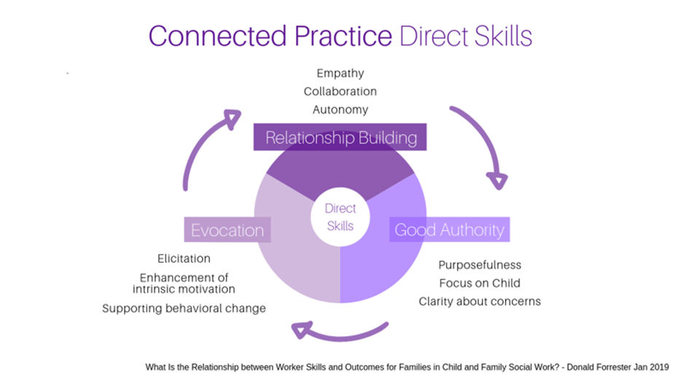

    - The stress on connections is important but it is also important for practitioners to be authoritative in their practice and to create behaviour change. The Forrester study showed that relationship building skills predicted better engagement but good authority and evocation had better outcomes.

    - East Sussex have taken this a step further and underlaid it with the importance of good assessment and analysis of risk:

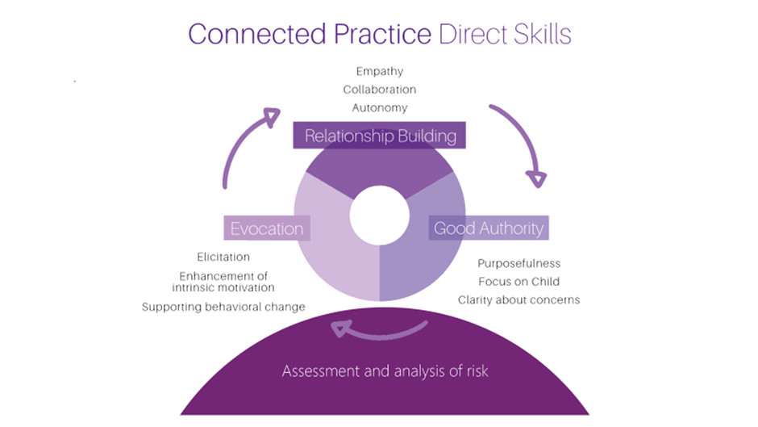

    - So, the fundamentals of Connected Practice Direct skills are Relationship Building, Good Authority and Evocation
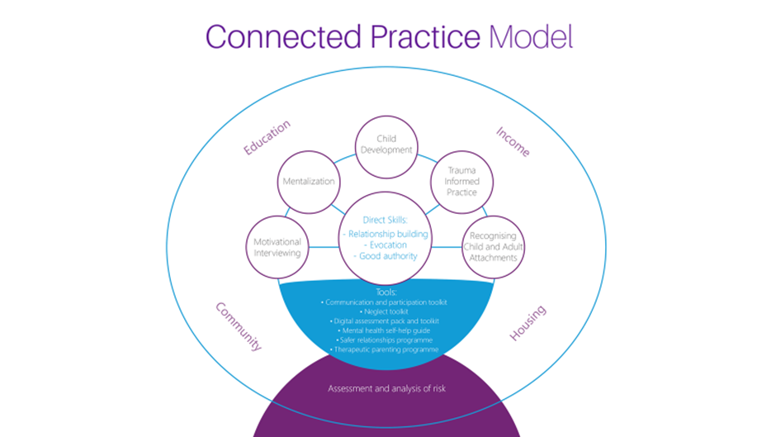

    - Ofsted judged East Sussex Children’s Service to be ‘outstanding’ in 2018 and commented on a culture where workers flourish allowing them to make a real difference to children and families with whom they work and children were at the heart of everything they do.

Who uses the model?
    - The model was developed in East Sussex and is used across the organisation within Early Help and all aspects of social care and is modelled by managers throughout the organisation.

    - The model is also used by the joint funded and jointly commissioned multi-disciplinary specialist SWIFT service. (Safeguarding with Intensive Family Treatment)

Evaluation and impact
    - The model is evaluated through a learning needs analysis across all services every two years which provides an in-depth overview of the key components of the model.

    - The Connected Practice model is now business as usual in East Sussex. Success and challenges are measured through embedded Quality Assurance processes like case file audits, practice observations, service user feedback, focus groups, “You said…We did”, compliments, complaints and comments, court feedback, workload analysis; staff health checks.

    - In terms of evidence of impact on the organisation East Sussex reports:
- 12% turnover of staff which is under the 16% national average,
- very few agency staff,
- very low vacancy rate,
- caseloads within national average,
- health surveys - 95 % reporting that they would recommend ESCC as an employer

  - Drivers and challenges
    - East Sussex was starting from a strong foundation, successive good inspection outcomes, relatively strong recruitment and retention, stable management. However, the organisation was not complacent and was on an unsustainable trajectory of high service demand and high costs which provided both a driver for change and a challenge.

    - The senior management team turned away from buying in a model of practice, and turned away from just looking at what are the problems. Instead they had a good look at how they could build on their strengths which were:
- a stable workforce
- manageable caseloads
- effective management oversight and frequent supervision
- culture of learning

    - Ensuring buy in and ownership is an acknowledged challenge of any management of change. Having decided not to buy an “off the shelf” system the starting point was talking to children, adults and social workers to find out what is realistic, doable and will work. In order for it to support a “one voice” approach it had to be based on the principles that chimed with workers, could be adapted to the home visiting form of delivering interventions and which children and families could easily grasp hold of too.

    - The Principal Social Worker started with conversations with children and families first to find out what kind of an organisation they wanted. The questions were loaded – “does social work make a difference?”

    - East Sussex set up a practitioners’ group with the remit of taking relationship-based practice to next step – clearly articulating what the framework is and what underpins the model. Managers started by thinking about what they were trying to achieve and worked with practitioners to work up words and images which have been used to inform the model and the branding.

    - Children, young people, families and social workers were consistently saying that the thing that made a difference was the quality of the relationship with the social worker and the understanding that the social worker was doing everything they could to keep the family together. We know that children’s development is shaped by the quality of the relationship within the family and with others. Therefore, in order to improve outcomes for children, we need to concentrate on improving the quality of their relationships within their family – BUT what does the social worker need to deliver this? – they need to feel connected back at the ranch, back to their team, to their manager – and their manager needs to feel connected with their manager and so on up to CEO – hence “Connected Practice”.

    - This, together with the Connected Practice development offer, encompassing intensive training on motivational interviewing, attachment and trauma informed practice, chimed with what social workers wanted to do and how they see their work with their families. People understood that they were trying to achieve a common approach and understanding regarding our families and carers. On a very pragmatic basis they got it – that we were going to have the same conversations about families because the conversation was framed around the child plan using language that was already in place.

    - These conversations were the same conversations to be had at all levels in the organisation. They would be asked by a practice manager asking about a child in need and the DCS talking to the AD or Head of Service about a high cost residential placement or Secure Accommodation application

- why is the family/ carer functioning as they are? How has past experience and trauma impacted on the current situation? (what are we worried about)
- what are the strengths that we can harness within this family, carer and extended family to create change? (what is working well)
- what can the practitioner contribute to support the family/ carer and improve their functioning in order to keep the child safe/ meet the child’s ongoing needs? (action)
- if there are current risks how can we keep the child and family / carer safe whilst this change work is occurring?
- what will it look like when the child is safe/ thriving? (how will we know when things have improved)

    - As outlined above one of the challenges is not to stand still or become complacent but to continuously learn and refresh. Part of keeping the model fresh and sustaining the change to support consistent good practice involves supporting managers, including senior manager. This has involved developing series of briefings that supports senior managers in developing a culture of excellent social work practice, having a clear developmental pathway for staff progression, understanding the lived experience of children and families, explores ways in which senior leaders can embed and quality assure the effectiveness of supervision within an organisation.

  - Funding and costs
    - The East Sussex model was developed and implemented using existing core local authority resources in a different way. The authority significantly reshaped their training and development offer, shedding training that did not support the Connected Practice model and this is constantly reviewed. The service developed their own resources and workforce development created the Learning Needs Assessment and the Principal Social Worker and her team used this to create the evaluation.

- Local Authority Contacts
Family Safeguarding Model
Bracknell Forest | Ann- Marie Ali | Lead Project Manager for Family Safeguarding Model |  | Anne-marie.ali@bracknell-forest.gov.uk
West Berkshire | Pete Campbell  Stephanie Atalla | Head of Children & Family Services  Service Manager |  | Pete.campbell1@westberks.gov.uk  Stephanie.atalla@westberks.gov.uk
Surrey | Neena Khosla | Programme Director Family Safeguarding |  | Neena.khosla@surreycc.gov.uk
Signs of Safety
Milton Keynes | Sophie Marshall | Principal Social Worker |  | Sophie.marshall@milton-keynes.gov.uk
Wokingham | Rachel Oakley  Emma Hovell | AD Quality Assurance and Safeguarding Standards  Project manager for SOS |  | Rachel.oakley@wokingham.gov.uk  Emma.hovell@wokingham.gov.uk
West Sussex | Lisa Reid | Snr Improvement Lead |  | Lisa.Reid@westsussex.gov.uk
Windsor & Maidenhead | Shungu Chigocha | Principal Social Worker |  | Shungu.chigocha@achievingforchildren.org.uk
Medway | Amanda Mathur | Principal Social Worker |  | Amanda.mathur@medway.gov.uk
Kent | Susan Ashmore | Principal Social Worker |  | Susan.ashmore@kent.gov.uk
The Hampshire Approach
Hampshire | Kavitha Maxy | Principal Social Worker |  | Kavitha.maxy@hants.gov.uk
Hampshire | Step How | Head of Strategy and Operations East |  | Stephanie.how@hants.gov.uk
Isle of Wight | Kathy Marriott | Head of Strategy and Operations Isle of Wight |  | Kathy.marriott@iow.gov.uk
Isle of Wight | Debbie Price | Principal Social Worker |  | Debbie.price@iow.gov.uk
The Team Around the Relationship
Brighton & Hove | Tom Stibbs |  | Principal Social Worker | Tom.stibbs@brighton-hove.gov.uk
Connected Practice
East Sussex | Nicola McGeown |  | Principal Social Worker | Nicola.mcgeown@eastsussex.gov.uk

https://www.gov.uk/government/publications/family-safeguarding-hertfordshire-an-evaluation
https://www.signsofsafety.net/what-is-sofs/
https://www.gov.uk/government/publications/signs-of-safety-practice-in-childrens-services-an-evaluation
https://www.signsofsafety.net/product/signs-of-safety-comprehensive-briefing-paper-2/
https://whatworks-csc.org.uk/evidence/evidence-store/intervention/signs-of-safety/
https://knowledgebank.signsofsafety.net/resources/signs-of-safety-research/research-articles/you-cant-grow-roses-in-concrete-part-2)
https://innovationcsc.co.uk/projects/active-agents-for-change/
https://files.ofsted.gov.uk/v1/file/50083968
https://www.brighton-hove.gov.uk/sites/brighton-hove.gov.uk/files/Social%20Work%20-%20Brighton%20and%20Hove%27s%20Vision.pdf
https://www.brighton-hove.gov.uk/sites/brighton-hove.gov.uk/files/Evaluation%20of%20relationship-based%20practice%20in%20BHCC%20July%202017.pdf
https://nicolamcgeown.wordpress.com/2015/03/10/welcome-to-our-blog-and-fantastic-new-resource-single-source/

